**Chardon is going to the Musicals**

Back by popular demand, **Munson PTO** is coordinating group tickets for the entire 2018-19 Broadway series at

**PLAYHOUSE SQUARE**!

Musicals include: Hello, Dolly!

Les Miserables

Chicago

Rudolph the Red-Nosed Reindeer: The Musical

Rodgers + Hammerstein’s Cinderella

Miss Saigon

School of Rock

A Bronx Tale

Dear Evan Hansen

Come From Away

**Hello, Dolly!** – Sunday, 10/21/18 @ 1pm

Mezzanine D $41/ticket *prices include all fees

Balcony A $20/ticket

checks payable to Munson PTO by 9/11/18

**Les Miserables** – Sunday, 11/3/18 @ 1:30pm

Mezzanine B $58/ticket

Orchestra C $41/ticket

Balcony A $20/ticket

checks payable to Munson PTO by 9/25/18

CLSD will not provide transportation or parking for any of the above events. All students must be accompanied by an adult. Tickets will be sold on a first come first serve basis. Please contact Elizabeth Fullerman at [efullerman@hotmail.com](mailto:efullerman@hotmail.com) or 216-299-5141 with any questions.

Chardon is going to the Musicals

Order Form

Name: ____________________________________________

Telephone or email: _____________________________

School: ___________________________________________

**Hello, Dolly!** – Sunday, 10/21/18 @ 1pm

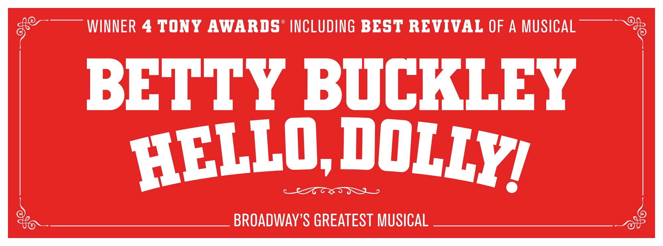

Mezzanine D $41/ticket

Balcony A $20/ticket

number of tickets: ________

specify Mezzanine vs Balcony: _______________

**check payable to Munson PTO by 9/11/18**

Ticket prices include all fees. The order form will change depending on show and payment date. If you are interested in buying tickets for more than one musical, please comment below and I will contact you directly. Thank you, Elizabeth Fullerman

_______________________________________________________________

_______________________________________________________________

Chardon is Going to the Musicals

Order Form

Name: ____________________________________________

Telephone or email: _____________________________

School: ___________________________________________

**Les Miserables** – Sunday, 11/3/18 @ 1:30pm

Mezzanine B $58/ticket

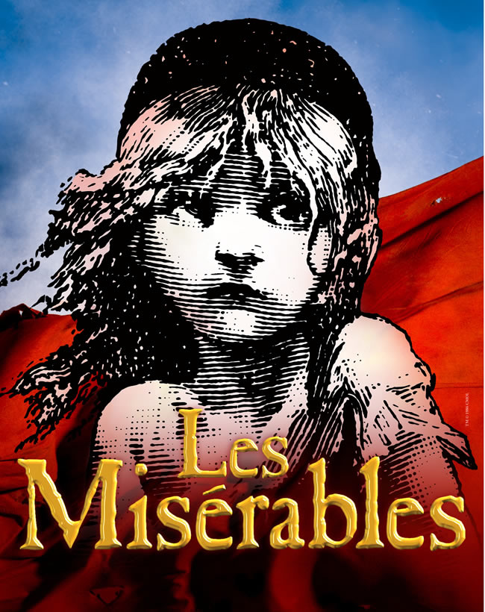

Orchestra C $41/ticket

Balcony A $20/ticket

number of tickets: ________

specify seat location: _______________

**check payable to Munson PTO by 9/25/18**

Ticket prices include all fees. The order form will change depending on show and payment date. If you are interested in buying tickets for more than one musical, please comment below and I will contact you directly. Thank you, Elizabeth Fullerman

_______________________________________________________________

_______________________________________________________________